|  |  |
| --- | --- |
|  | **2015** |
|  | Sardar Patel Institute of Technology  Amey Dileep Chousalkar, Roll No: 07, FYMCA. |

|  |
| --- |
| **[Helping hands]** |
| Project Report on Helping Hands Masters of Computer Applications Web Technology Project MCA Semester I Submitted By Amey Dileep Chousalkar. Roll no 30MCA 2015-2018Institute of Computer Science Mumbai Educational Trust University of Mumbai. |

Mini-project report on

1. **Technology Business Incubator**

By

**VirajRaut**

**(44)**

**DivyaRawat**

**(45)**

**OmkarRojekar**

**(46)**

Under the guidance of

**Internal Supervisor**

Indranil Sarkar / Sandesh Patil



Department of Master In Computer Applications

Sardar Patel Institute of Technology

University of Mumbai

2015 -16



**PROJECT EVALUATION CERTIFICATE**

This is to certify that the following students

**Amey Dileep Chousalkar**

**(07)**

**Vishesh Dahate**

**(08)**

**Kunal Rajeev Dalvi**

**(09)**

Have successfully completed the Mini-project report on **“NGO Management*”***, towards the fulfillment of First Year Web Technology & Web Project Development Lab Mini-Project for Lab L102 which is found to be satisfactory and is approved

At

SARDAR PATEL INSTITUTE OF TECHNOLOGY,

ANDHERI (W), MUMBAI.

INTERNAL EXAMINER EXTERNAL EXAMINER

**Acknowledgement**

I would like to thank my supervisors Mr. Sandesh Patil and Mr.Indranil Sarkar for this guidance and comment on various aspects of this project and for thoughtful contribution in my effort.

I would also like to express my gratitude to the staff of Master In Computer Application Department, Sardar Patel Institute of Technology for their co-operation.

I am also thankful to Sardar Patel Institute of Technology for providing me an opportunity to work in excellent working environment together with required resources.

Other known and unknown persons who helped me in my work and also deserve thanks for their co-operation . Last but not the least; I am very thankful to my friends for providing me a valuable assistance during my work.

**CERTIFICATE OF APPROVAL**

This is to certify that the project report titled

**Helping Hands**

Is a bonafide record of the work done by

Amey Dileep Chousalkar

Roll No 07

This project is approved as Web Technology Project for

MCA, Semester I,

University of Mumbai

Examiner Examiner

Sign : _________ Sign : _________

Name: _________ Name: _________

Date : _________ Date : _________

**Index**

|  |  |  |
| --- | --- | --- |
| **Contents** | | |
| **Sr. No** | **Page Title** | **Page No** |
|  | **Abstract** | **IV** |
|  | **List of Tables and Figures** | **VII** |
| 1 | **Introduction**   * 1. Problem Definition   2. Objective & Scope   3. Existing System   4. Proposed System   5. Assumptions & Constraints   6. System Requirements | **1** |
| 2 | **Software Requirement Specification[SRS]**  2.1 Introduction | **3** |
| 3 | **Project Analysis & Design**  3.1 Methodologies Adapted  3.1.1 Detailed life Cycle of the Project  3.2 Use Case Diagram  3.3 Database Schema/ Design  3.3.1 E-R diagram  3.3.2 DFD diagram | **15** |
| 4 | **Project Implementation & Testing**   * 1. Work Break down Structure   2. Gantt Chart   3. Pert Chart and PERT Table   4. Code with reference to design   4.5 Snapshot of UI & Reports | **36** |
| 5 | **Future Enhancements** | **39** |
| 6 | **Limitations &Conclusion** | **45** |
| 7 | **Bibliography** | **50** |
| 8 | **Glossary of terms** | **52** |

**Abstract**

As more and more individuals respond to the growing needs within their communities, volunteers are giving back in record numbers. Further, many of today’s volunteers are professionals with valuable experience.

It is more important now than ever for nonprofit organizations to find ways to manage utilize and maximize volunteers. Our website provides the tools you need to efficiently recruit, track, and manage volunteers — ultimately helping you expand your capacity to meet your mission.

At its most basic level, volunteer management is the selection, supervision and engagement of volunteers. But it’s much more than that. Volunteer management opens an organization to the community and allows citizens to get involved.

The experts in the field of volunteer management are the individuals already out there, doing the day to day work of finding, matching, supporting, and recognizing volunteers. In other words: you. With that in mind, we're offering up a website which deals with these needs. All they have to do is to register on the website and fill up all details required. We’d try to find the best possible NGO for them according to their requirement and keep them posted about it through their contact details.

For the NGOs, finding volunteers is a difficult work. You need to do outreach in the community – starting with your organization's existing networks and working your way out. You never know what kind of response you'll get. Or if you'll find the right kind of volunteers – those folks who have the skills, motivations, and attitudes that fit best with your organization's volunteer program. We make it simpler for them too. Volunteers who are truly interested in this job will apply, others won’t bother registering. So at the end, we know who’s worth it and hence we’ll place them according. Short-term, Long-term volunteer-ship is another feature worth considering. Also website provides enough publicity to the works of NGOs.

**Introduction**

Helping Hands, a nonprofit organization which work on education, health, environment and income generation programs by partnering with credible and evaluated NGOs in India. Through our various programs of virtual volunteering, workshops & training and skill development we work towards empowering lives to provide sustainable livelihoods. We focus on making all our programs an inclusive process in order to build individual and collective platforms to contribute meaningfully in the social development sector. Our mission is To provide platforms for exchange of ideas, skills and learning in the social development sector & our vision is to bring about positive social change**.**

Helping Hands sensitizes and encourages students and individuals to engage in volunteering/ internship opportunities; in the space of education, health, environment, and income generation Programs are assigned after assessing and matching one’s skills, experience, time availability and areas of interest with the program’s needs. Volunteers can choose to work in either Helping Hands office as an intern/ volunteer or choose to work with any of the partner NGOs.

It is our endeavor to empower this segment of our population to have access to means of livelihood as well as personality development training. We have identified missing links in the chain that limit opportunities of employment for the urban poor community and are continuously engaged in skill development training sessions and curriculum. Presentations are made in various colleges and schools throughout the year so as to encourage student volunteers to take part in volunteering. Helping Hands has always encouraged international volunteering as well.. We encourage students, individuals and corporate professionals to engage in community focused initiatives; in the space of education, health, environment, income generation etc.

After the period of volunteering is completed, the volunteer’s services and work are recognized through a ‘Certificate of Appreciation’ issued by Joining Hands.

**Problem Definition**

Volunteer Management System is defined as software that actually has "volunteer" somewhere in its official description**.**

Volunteer Impact softwares are for managing volunteers in nonprofits, school districts and government agencies. Volunteer Impact can help you:

* Recruit volunteers through your website, Facebook, Twitter or other social media sites
* Streamline the application process and reduce the time you spend doing data entry
* Track volunteer skills, qualifications and trainings
* Create schedules and scheduling rules that engage volunteers in the process while keeping you in control
* Schedule groups of volunteers and the right number of placements will be filled in the system!
* Track and celebrate volunteer outputs or achievements

Community Hub softwares are for volunteer centers and other volunteer matching organizations**.**Whether you want a virtual volunteer opportunities portal or an entire community approach to volunteer engagement, and whether you are one community or a collection of many, Community Hub can be configured to meet different needs.

* Participating nonprofits can add their own volunteer opportunities
* Volunteers can search in a variety of ways that meet their preferences
* Community Hub can help you raise the bar on volunteer management across  the entire community
* Track all contact information about volunteers (postal address, phone number, email, etc.)
* Track where a volunteer applicant is in the volunteer orientation/participation process (completed application, completed orientation, current assignment or role, has a photo release form on file, inactive because of illness, permanently withdrawn, etc.)
* Track volunteer / community / constituent participation in events, online fora, etc.
* Track volunteer hours and/or contribution / accomplishment by week, month, quarter or
* Their assignments, tracks client and paid staff feedback about their work, etc.)
* Track volunteer skills
* It is described on its web site (preferably the home page) by its developer as something that can be used for *volunteer management* or *volunteer support*

What's probably most important in choosing volunteer management System is that it can track ALL of your volunteers - volunteers who take on defined roles for year (board members, a project leader, mentors, counselors, a volunteer web master, etc.), volunteers who help only at onsite events or one-time activities (help at a beach cleanup, usher at a performance, etc.), volunteers who engage primarily online (helping by assignment, or by project, rather than taking on a role - that includes people who take on so-called micro volunteering), etc.

**Existing Systems:**

Initially, offline methods were used to manage volunteers for NGOs.

It required the following things to be done manually.

* PLAN AND ORGANIZE
* POLICIES AND PROCEDURES
* VOLUNTEER RECRUITMENT
* SCREENING, INTERVIEWING AND PLACEMENT
* ORIENTATION AND TRAINING
* SUPERVISION
* VOLUNTEER PERFORMANCE EVALUATION
* RETENTION AND RECOGNITION
* MEASURING VOLUNTEER PROGRAM EFFECTIVENESS

The data collection method, or evaluation, should gather the best data the budget will allow and provide adequate time for gathering and analyzing the data. The evaluation report should be a succinct statement that summarizes the results or outcomes of the program activities.

Proposed System:

* 1. **Assumptions & Constraints**

The following assumptions and constraints are used:

1.System must be accessible from anywhere through internet.

2.The privacy of the customers must be protected against unauthorized use.

3.Every customer must be given an unique identification number

4. The first name and last name field must consist of letters only of maximum 30 characters long.

**1.6 System Requirements**

**Hardware Requirement:-**

Processor                   :       Intel Core Duo 2.0 GHz or more

RAM                         :       512MB or More

Hard disk                  :       20GB or more

Monitor                     :       15” CRT, or LCD monitor

Keyboard                   :       Normal or Multimedia

Mouse                     :       Compatible mouse

**Software Requirement:-**

Operating System : windows XP, Windows 07

Server : Xampp 5.6.1

1. **Software Requirement Specification [SRS]**

**2.1 Introduction**

The “Technology Business Incubation Center” was established in Sardar Patel Institute of Technology, Bhavan’s Campus, Andheri (W) in 2009. It is an initiative to nurture a culture of entrepreneurship in the creative minds of young engineers, so that their ideas are implemented into newer products or services that have marketing potential. This center, started and supported by S P. I. T. provides all the required infrastructure and support for technology- based entrepreneurship .It helps and motivates young innovators to become successful entrepreneurs.

This project Technology Business Incubator is an online website in which admin can add the startup companies, companies can add job vacancies and users can register themselves online and apply for job. This system provides online help to the users all over the world. Using web recruitment systems like recruitment websites or jobsites also play a role in simplifying the recruitment process. Such websites have facilities where prospective candidates can upload their CV’s and apply for jobs suited to them. Such sites also make it possible for recruiters and companies to post their staffing requirements and view profiles of interested candidates. Earlier recruitment was done manually and it was all at a time consuming work. Now it is all possible in a fraction of second. It is all done online without much time consuming. Today’s recruitment applications are designed to do a whole lot more than just reduce paperwork. They can make a significant contribution to a company’s marketing and sales activity.

A quick look at the overall trends in Online recruiting shows the rise in the importance of marketing the web site, online training, dawn of video interviews and emergence of professional Internet Recruiters. Online recruiting and online recruiting systems, with its emphasis on a more strategic decision making process is fast gaining ground as a popular outsourced function.

1. **Project Analysis and design**

**3.1 Methodologies used**

**PHP**

PHP is a comparatively simpler language to use than ASP.net. Initially, PHP was written in the C programming language to put back a set of scripts in Perl. That is the reason why coding in PHP rest simple event o day. Many developers find themselves to be more at ease with the user-friendly nature of PHP when it comes to coding. However, opponents also count this advantage of PHP as a disadvantage. Some of them maintain that the language of PHP has not been rationalized much, and hence It is still quite outdated and even, somewhat unwieldy for coding. ASP.net, which is a comparatively new development, has a lot of options when it comes to languages. Here, you can use languages such as C#, J#, C++and VB.net.

PHP has much better support for the database management system, MySQL. In fact, the very popular blogging platform, Word Press uses there doubtable combination of PHP coding on MySQL for its content management system, which includes about hundreds of thousands of blog posts every single day. Another very popular and frequently updated service that uses the mixture of PHP and MySQL is Wikipedia. ASP.net canals o support MySQL, but PHP is unanimously sleet, by the heaps and classes alike, for its great support for this database management system.

When it comes to support, PHP wins over ASP.net. The main reason for this is that PHP is an open source. Hence, the support can come freely from all over the world. In most cases, PHP fixes are made instantaneously. Being open source also guarantees that there are very few hurdles in PHP. While, ASP.net could take a while to make fixes. That is because it is owned by Microsoft, and it is the development team of Microsoft that will need to react to the support query. That could take more time than the world wide open source support that PHP is able to get. Most PHP supports can be directly found online by doing a simple search on the Internet. Some of the providers of support for PHP are Z end, Nu Sphere and Think PHP.

PHP is an open source programming language, which means it is free for anyone to use. Programmers can develop PHP applications virtually at no cost, because PHP is free to use.

**XAMPP SERVER**

XAMPP is a free and open source cross-platform web server solution stack package, consisting mainly of the Apache HTTP Server, MySQL database, and interpreters for scripts written in the PHP and Perl programming languages.



XAMPP is used for web development on your local machine, as opposed to directly on your web space. It allows you to tinker and test out changes on your personal computer before making those changes publicly online. The XAMPP package is simply an easy way to install all the vital web server parts all at once, though it’s just as possible to install them all individually and by hand instead. Some people prefer to do that for a better understanding of the individual setup for each piece of software. If you prefer to focus on web development, though, XAMPP should be perfectly acceptable.

**CSS**

CSS Stands for "Cascading Style Sheet." Cascading style sheets are used to format the layout of Web Pages. They can be used to define text styles, table sizes, and other aspects of Web pages that previously could only be defined in a page's HTML.

CSS helps Web developers create a uniform look across several pages of a Web site. Instead of defining the style of each table and each block of text within a page's HTML, commonly used styles need to be defined only once in a CSS document. Once the style is defined in cascading style sheet, it can be used by any page that references the CSS file. Plus, CSS makes it easy to change styles across several pages at once. For example, a Web developer may want to increase the default text size from 10pt to 12pt for fifty pages of a Web site. If the pages all reference the same style sheet, the text size only needs to be changed on the style sheet and all the pages will show the larger text.

While CSS is great for creating text styles, it is helpful for formatting other aspects of Web page layout as well. For example, CSS can be used to define the cell padding of table cells, the style, thickness, and color of a table's border, and the padding around images or other objects. CSS gives Web developers more exact control over how Web pages will look than HTML does. This is why most Web pages today incorporate cascading style sheets.

**HTML**

HTML is a computer language devised to allow website creation. These websites can then be viewed by anyone else connected to the Internet. It is relatively easy to learn, with the basics being accessible to most people in one sitting; and quite powerful in what it allows you to create. It is constantly undergoing revision and evolution to meet the demands and requirements of the growing Internet audience under the direction of the W3C (World Wide Web Committee), the organization charged with designing and maintaining the language.

The definition of HTML is Hyper Text Markup Language.

* Hyper Text is the method by which you move around on the web — by clicking on special text called hyperlinks which bring you to the next page. The fact that it is hyper just means it is not linear — i.e. you can go to any place on the Internet whenever you want by clicking on links — there is no set order to do things in.
* Markup is what HTML tags do to the text inside them. They mark it as a certain type of text (italicized text, for example).
* HTML is a Language, as it has code-words and syntax like any other language.

HTML consists of a series of short codes typed into a text-file by the site author — these are the tags. The text is then saved as an html file, and viewed through a browser, like Internet Explorer or Other internet browser. This browser reads the file and translates the text into a visible form, hopefully rendering the page as the author had intended.

**JavaScript.**

JavaScript is a high level, dynamic, un typed, and interpreted programming language. It has been standardized in the ECMA Script language specification.  Alongside HTML and CSS, it is one of the three essential technologies of World Wide Web content production; the majority of websites employ it and it is supported by all modern web browsers without plug-ins. JavaScript is prototype-based with first-class functions, making it a multi-paradigm language, supporting object-oriented, imperative, and functional programming styles. It has an API for working with text, arrays, dates and regular expressions, but does not include any I/O, such as networking, storage or graphics facilities, relying for these upon the host environment in which it is embedded.

Despite some naming, syntactic, and standard library similarities, JavaScript and Java are otherwise unrelated and have very different semantics. The syntax of JavaScript is actually derived from C, while the semantics and design are influenced by the self and Scheme programming languages.

**3.1.1Detailed Life Cycle of the project**

**Waterfall Model**

Waterfall approach was first SDLC Model to be used widely in Software Engineering to ensure success of the project. In "The Waterfall" approach, the whole process of software development is divided into separate phases. In Waterfall model, typically, the outcome of one phase acts as the input for the next phase sequentially.

Following is a diagrammatic representation of different phases of waterfall model.

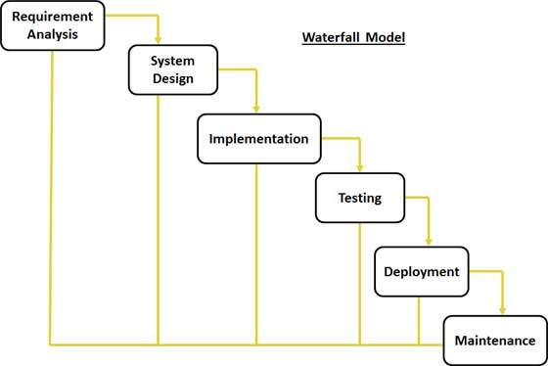

Fig.3.1.1 Waterfall Model

The sequential phases in Waterfall model are:

* **Requirement Gathering and analysis:** All possible requirements of the system to be developed are captured in this phase and documented in a requirement specification doc.
* **System Design:** The requirement specifications from first phase are studied in this phase and system design is prepared.
* **Implementation:** With inputs from system design, the system is first developed in small programs called units, which are integrated in the next phase.
* **Integration and Testing:** All the units developed in the implementation phase are integrated into a system after testing of each unit.
* **Deployment of system:** Once the functional and non functional testing is done, the product is deployed in the customer environment or released into the market.
* **Maintenance:** There are some issues which come up in the client environment. To fix those issues patches are released.
* **2 Use Case Diagram**
* **3.2.1 Use Case Diagram for Admin**

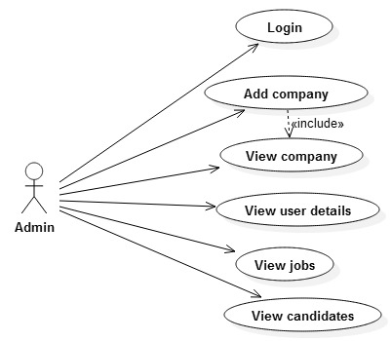

**Fig.3.2.1 Admin Use Case Diagram**

* **3.2.2 Use Case Diagram for Company**

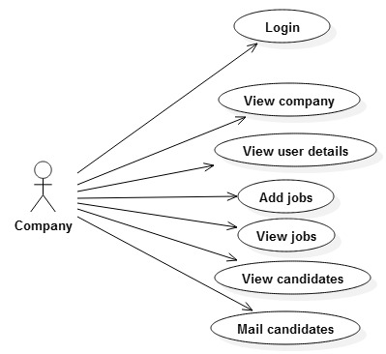

**Fig.3.2.2Company Use Case Diagram**

* **3.2.3 Use Case Diagram for User**

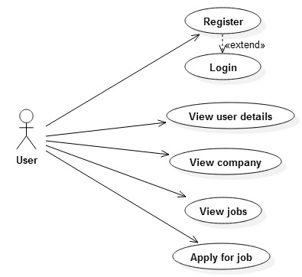

**Fig.3.2.3User Use Case Diagram**

**DFD diagram**

**Context Level**

ER DIAGRAM

**Contact**

**NGO Registration**

**Volunteers Registrations**

**TABLE DESCRIPTION**

VOLEUNTEER

|  |  |  |
| --- | --- | --- |
| **Sr. No.** | **Coloumn Name** | **Data Type** |
| 1 | First Name | VarChar(30) |
| 2 | Last Name | VarChar(30) |
| 3 | Date of Birth | Text |
| 4 | Mobile No. | Text |
| 5 | Gender | Text |
| 6 | Address | Text |
| 7 | City | Text |
| 8 | Pincode | Text |
| 9 | State | VarChar(30) |
| 10 | Country | VarChar(30) |
| 11 | Type of NGO | VarChar(30) |
| 12 | Time | Time |
| 13 | Work Experience | Text |

NGO

|  |  |  |
| --- | --- | --- |
| **Sr. No.** | **Column Name** | **Data Type** |
| 1 | Name | Varchar(20) |
| 2 | User Name | Text |
| 3 | Password | Text |
| 4 | Email Id | Text |
| 5 | Mobile | Text |
| 6 | City | Text |
| 7 | State | Text |
| 8 | Type | Text |
| 9 | Profile | Text |
| 10 | Coordination | Text |

CONTACT

|  |  |  |
| --- | --- | --- |
| **Sr. No.** | **Column name** | **Data Type** |
| 1 | Name | VarChar (20) |
| 2 | Email Id | Text |
| 3 | Mobile No. | Int(10) |
| 4 | Message | Text |

**SCREEN SHOTS**

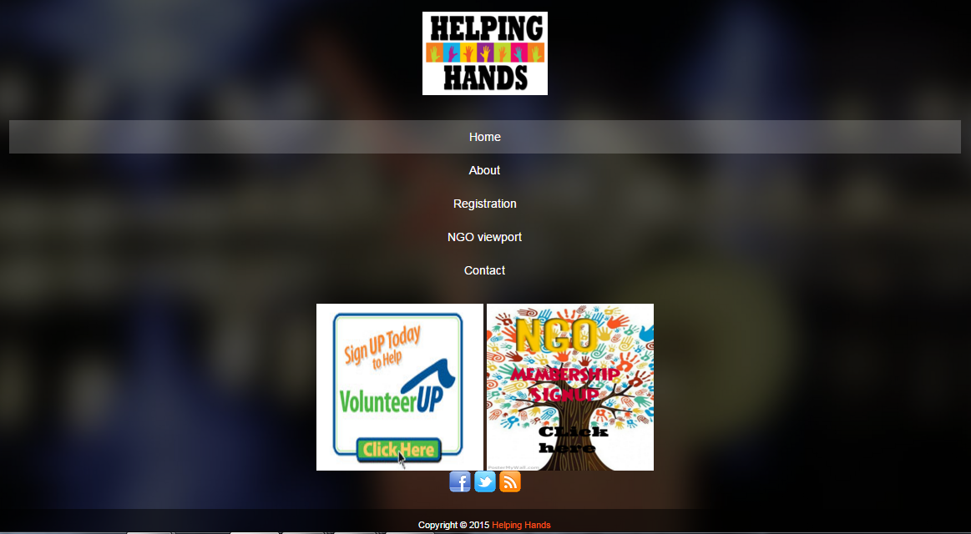

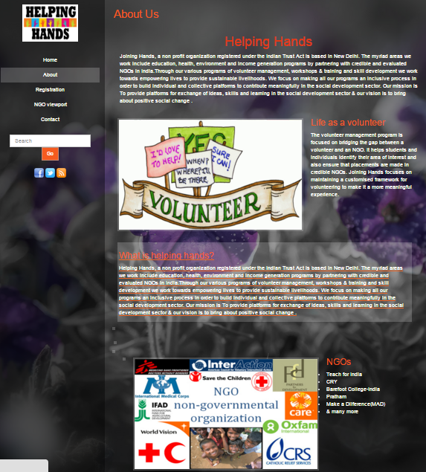

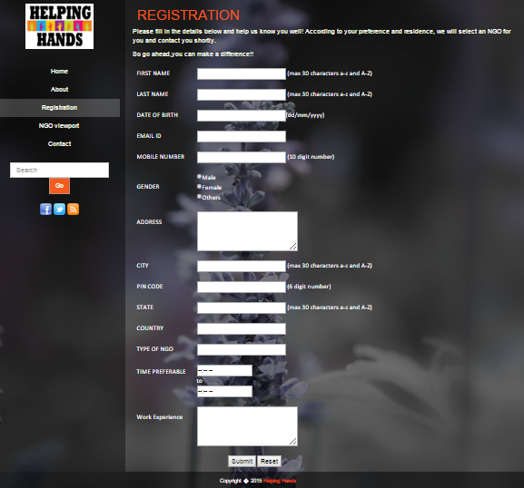

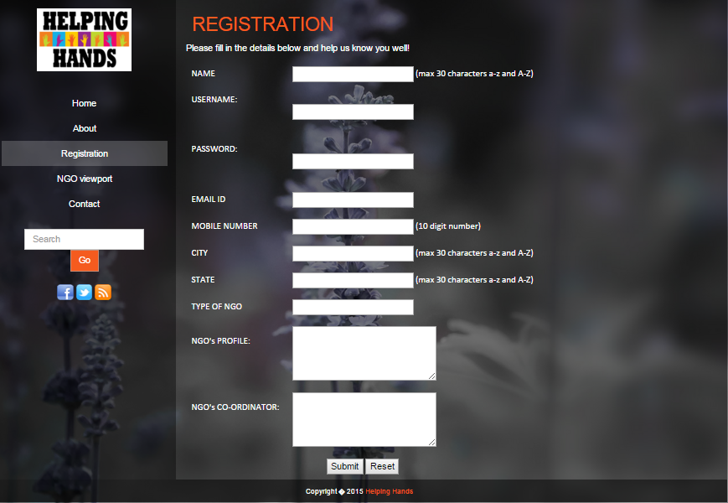

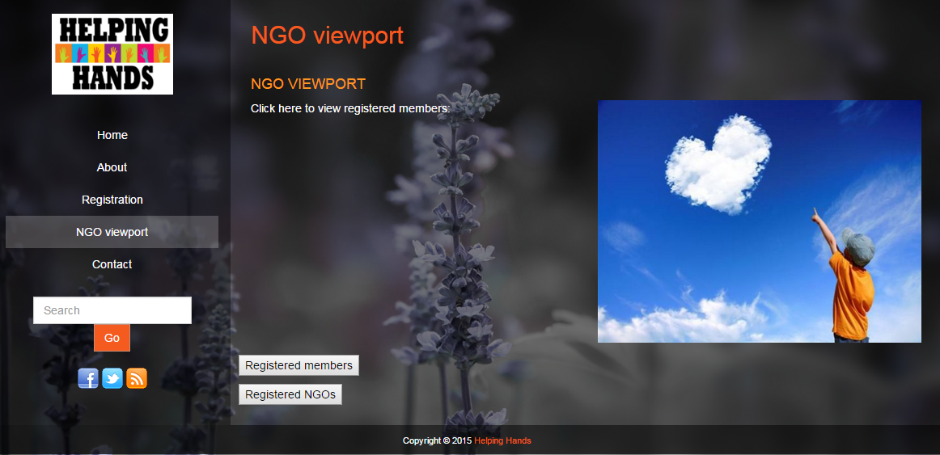

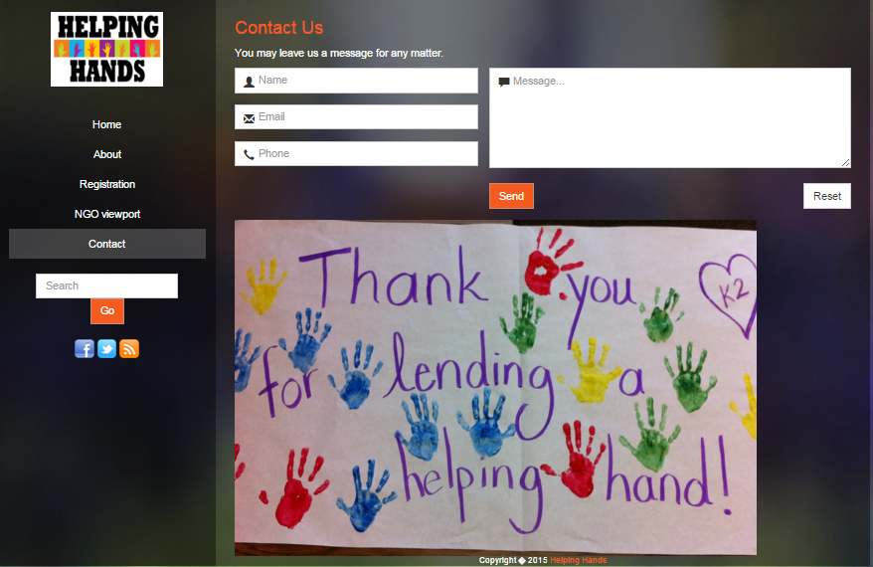

**CONCLUSION**

The Helping Hands Team will be useful for people who are willing to work for an NGO. There are many people who have time and eagerness to work for the betterment of the society. The site enables to browse through various NGOs which are categorized activity-wise that is for children, orphans, aged people, women etc. The Team helps in going through each NGO and finding the best suitable NGO for us. Furthermore it helps to track an NGO with the details given therein. This helps the NGOs in attracting more and more persons for charity.

The NGOs are not required to depend upon publicity through various sources for inducing and attracting people to volume for doing charitable work. The site also enables to enter contact details of the person interested in participating in social work conducted by the NGO. The NGO can then contact the concerned person and make use of the services of the person interested. The seminars, workshops to be conducted by the NGO can also be displayed for the benefit of the volunteers. Interactive chat sessions can also be conducted in chat rooms to answer NGO related queries of the volunteer’s online. All these facilities are not just for the benefit of the volunteers but mainly for the NGOs who are not able to reach to the volunteers. It speeds up the process of work in getting the volunteers recruited and getting assistance from them.

Thus basically our Helping Hands Team acts as a platform for helping the volunteers be recruited for a particular NGO and help the needy people. This is beneficial for both volunteers and the NGOs and the people who need us. Our website has more or less achieved our goals. Thus, we have successfully planned and implemented the website with great effort and team work.

BIBLIOGRAPHY

Websites

* [www.w3schools.com](http://www.w3schools.com)
* [www.youtube.com](http://www.youtube.com)